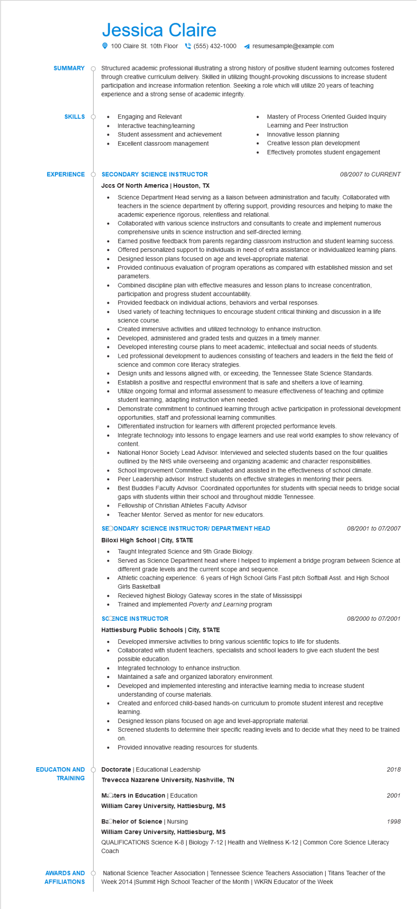
SUMMARY
Jessica Claire
100 Claire St. 10th Floor (555) 432-1000
resumesample@example.com
Structured academic professional illustrating a strong history of positive student learning outcomes fostered through creative curriculum delivery. Skilled in utilizing thought-provoking discussions to increase student participation and increase information retention. Seeking a role which will utilize 20 years of teaching experience and a strong sense of academic integrity.
SKILLS
•
Engaging and Relevant
•
Interactive teaching/learning
Mastery of Process Oriented Guided Inquiry Learning and Peer Instruction
Student assessment and achievement
Innovative lesson planning
•
Excellent classroom management
•
Creative lesson plan development
•
Effectively promotes student engagement
EXPERIENCE
SECONDARY SCIENCE INSTRUCTOR Jccs Of North America | Houston, TX
•
•
08/2007 to CURRENT
Science Department Head serving as a liaison between administration and faculty. Collaborated with teachers in the science department by offering support, providing resources and helping to make the academic experience rigorous, relentless and relational.
Collaborated with various science instructors and consultants to create and implement numerous comprehensive units in science instruction and self-directed lerning.
Earned positive feedback from parents regarding classroom instruction and student learning success. Offered personalized support to individuals in need of extra assistance or individualized learning plans.
• Designed lesson plans focused on age and level-appropriate material.
•
.
•
•
Provided continuous evaluation of program operations as compared with established mission and set parameters.
Combined discipline plan with effective measures and lesson plans to increase concentration, participation and progress student accountability.
Provided feedback on individual actions, behaviors and verbal responses.
Used variety of teaching techniques to encourage student critical thinking and discussion in a life science course.
Created immersive activities and utilized technology to enhance instruction.
Developed, administered and graded tests and quizzes in a timely manner.
Developed interesting course plans to meet academic, intellectual and social needs of students.
Led professional development to audiences consisting of teachers and leaders in the field the field of science and common core literacy strategies.
Design units and lessons aligned with, or exceeding, the Tennessee State Science Standards.
•
Establish a positive and respectful environment that is safe and shelters a love of learning.
•
•
•
•
Utilize ongoing formal and informal assessment to measure effectiveness of teaching and optimize student learning, adapting instruction when needed.
Demonstrate commitment to continued learning through active participation in professional development opportunities, staff and professional learning communities.
Differentiated instruction for learners with different projected performance levels.
Integrate technology into lessons to engage learners and use real world examples to show relevancy of content.
National Honor Society Lead Advisor. Interviewed and selected students based on the four qualities outlined by the NHS while overseeing and organizing academic and character responsibilities. School Improvement Commitee. Evaluated and assisted in the effectiveness of school climate. Peer Leadership advisor. Instruct students on effective strategies in mentoring their peers. Best Buddies Faculty Advisor. Coordinated opportunites for students with special needs to bridge social gaps with students within their school and throughout middle Tennessee. Fellowship of Christian Athletes Faculty Advisor
· Teacher Mentor. Served as mentor for new educators.
SECONDARY SCIENCE INSTRUCTOR/ DEPARTMENT HEAD
Biloxi High School | City, STATE
. Taught Integrated Science and 9th Grade Biology.
•
08/2001 to 07/2007
Served as Science Department head where I helped to implement a bridge program between Science at different grade levels and the current scope and sequence.
Athletic coaching experience: 6 years of High School Girls Fast pitch Softball Asst. and High School Girls Basketball
Recieved highest Biology Gateway scores in the state of Mississippi
Trained and implemented Poverty and Learning program
SCCENCE INSTRUCTOR
Hattiesburg Public Schools | City, STATE
08/2000 to 07/2001
Developed immersive activities to bring various scientific topics to life for students.
•
Collaborated with student teachers, specialists and school leaders to give each student the best possible education.
Integrated technology to enhance instruction.
•
Maintained a safe and organized laboratory environment.
•
Developed and implemented interesting and interactive learning media to increase student
understanding of course materials.
Created and enforced child-based hands-on curriculum to promote student interest and receptive learning.
Designed lesson plans focused on age and level-appropriate material.
Screened students to determine their specific reading levels and to decide what they need to be trained
on.
•
Provided innovative reading resources for students.
2018
2001
EDUCATION AND TRAINING
Doctorate Educational Leadership
Trevecca Nazarene University, Nashville, TN
Moters in Education | Education
William Carey University, Hattiesburg, MS
Bachelor of Science | Nursing
William Carey University, Hattiesburg, MS
QUALIFICATIONS Science K-8 | Biology 7-12 | Health and Wellness K-12 | Common Core Science Literacy
Coach
AWARDS AND AFFILIATIONS
National Science Teacher Association | Tennessee Science Teachers Association | Titans Teacher of the Week 2014 |Summit High School Teacher of the Month | WKRN Educator of the Week
1998

